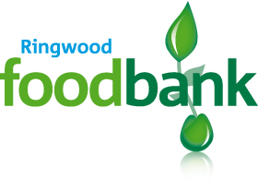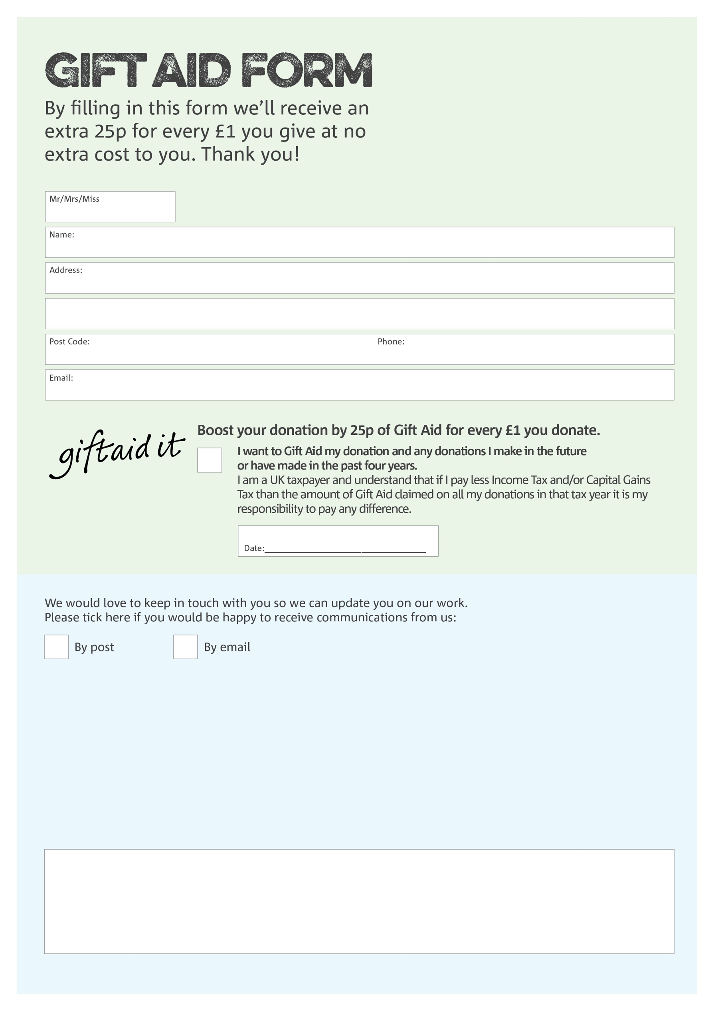

**Data protection**

Ringwood Foodbank is committed to protecting your privacy and will process your personal data in accordance with the Data Protection Act 1998. Ringwood Foodbank collects information to keep in touch with you and supply you with information relating to our work. Ringwood Foodbank will never sell or pass your details to anyone who isn’t directly working on our behalf.

You can change your preferences any time by contacting us on 01425 600 134 or emailing us at

[info@ringwood.foodbank.org.uk](mailto:info@ringwood.foodbank.org.uk)

Charity Number 1152574 Registered in England & Wales