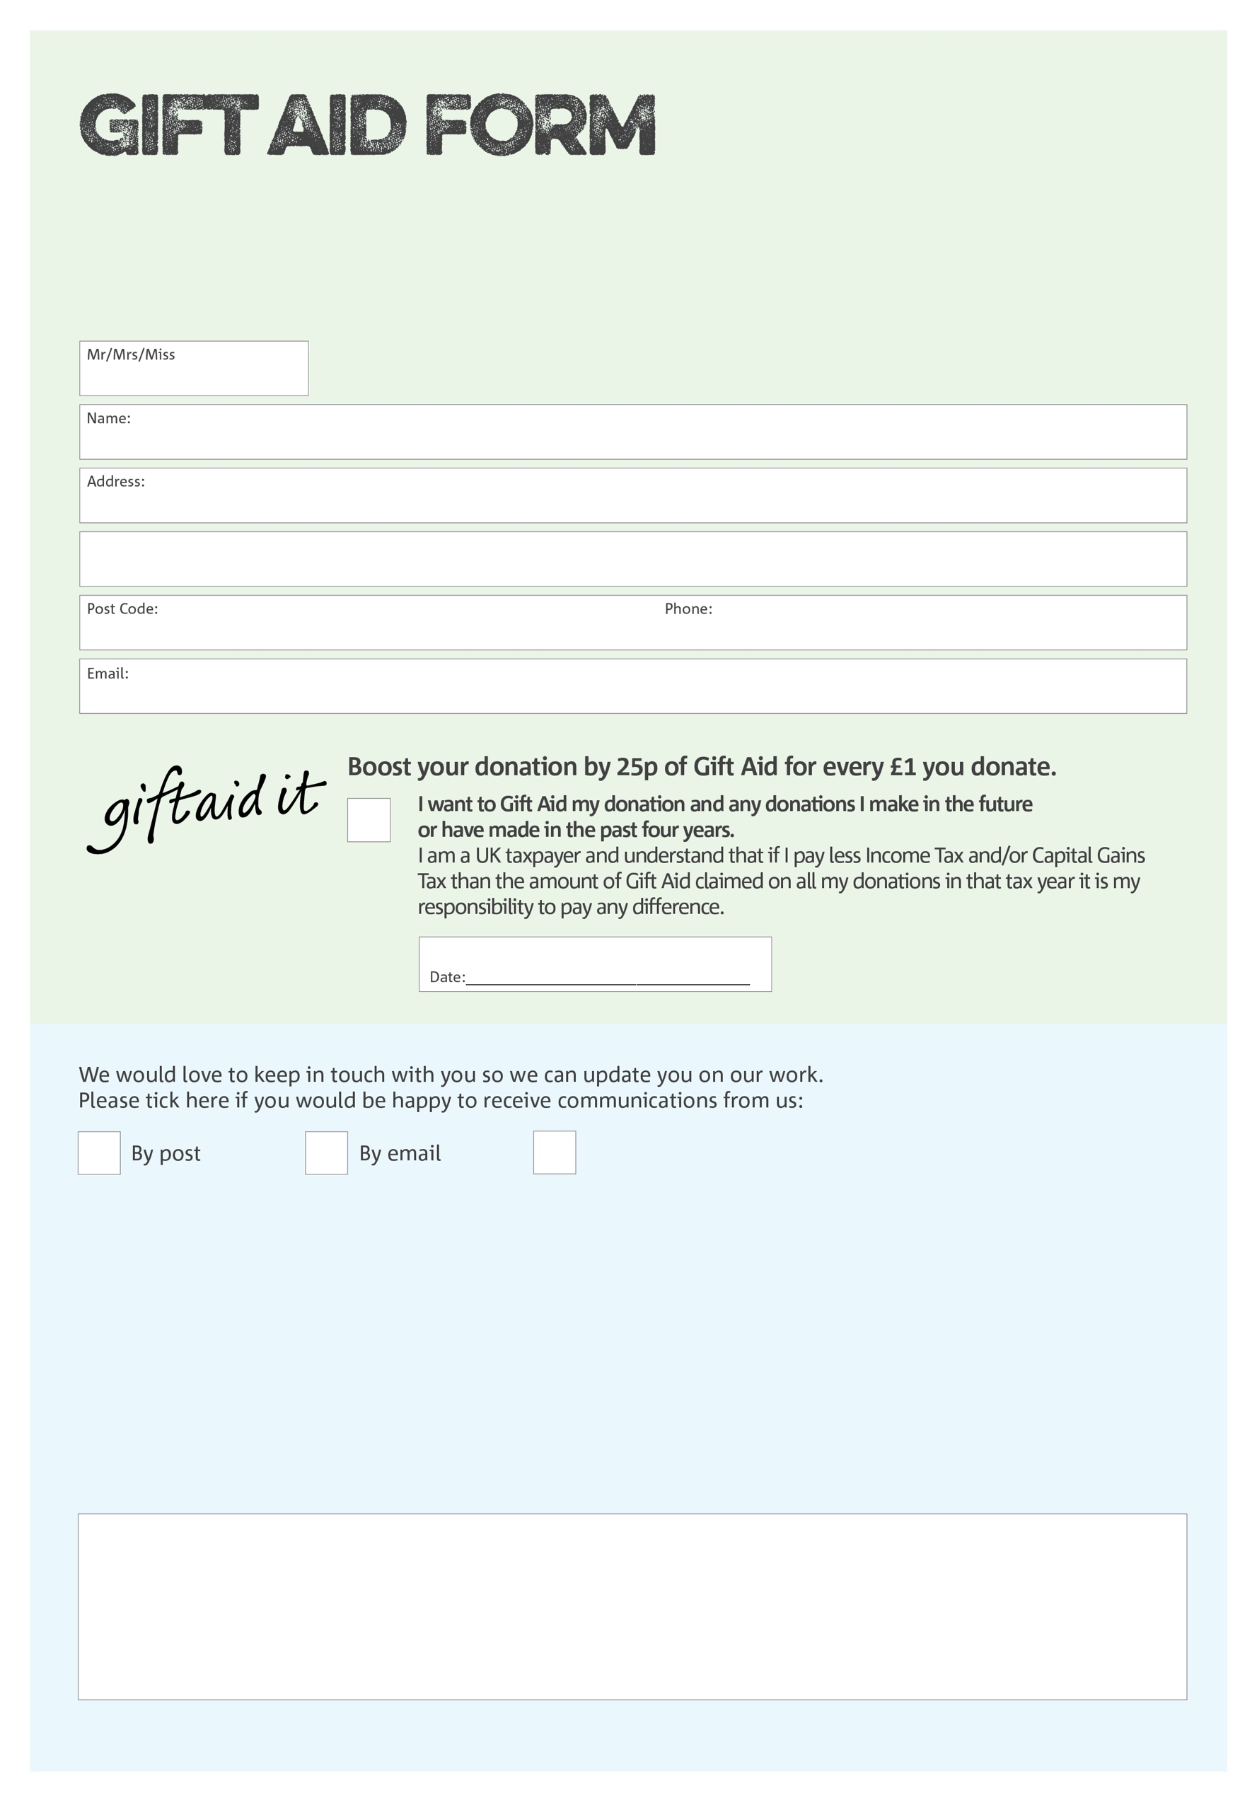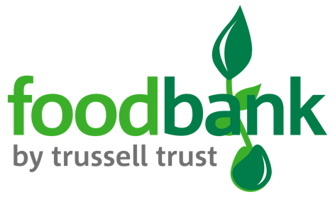

By filling in this form Ringwood Foodbank will receive an extra 25p for every £1 you give at no extra cost to you. Thank you!

You can change your preferences any time by contacting us on 01425 600 134 or emailing us at

<info@ringwood.foodbank.org.uk>

I do not wish to receive future communications from Ringwood Foodbank

**Data protection**

Ringwood Foodbank is committed to protecting your privacy and will process your personal data in accordance with the Data Protection Act 1998. Ringwood Foodbank collects information to keep in touch with you and supply you with information relating to our work. Ringwood Foodbank will never sell or pass your details to anyone who isn’t directly working on our behalf.

We would love to know why you have chosen to donate to Ringwood Foodbank. If you would like to share your motivation let us know below:

Charity Number 1152574. Registered in England & Wales