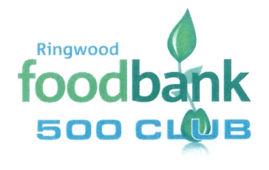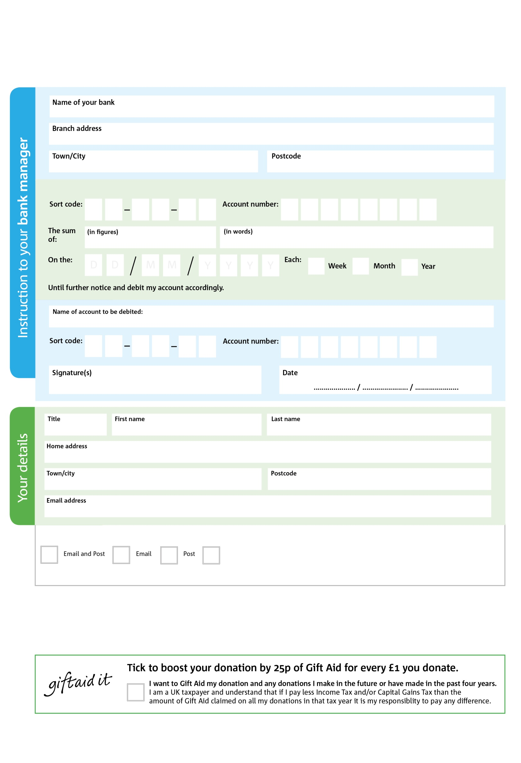

Reg. Charity No: 1152574 | Reg. in England & Wales ***Thank you***

**Please pass this form onto the foodbank, using the foodbank’s address at the bottom, who will save a copy for their records. They will then send it onto your named bank or building society.**

5

V

9

V

1

V

3X

V

3

V

6

V

3

V

3

V

7

3

2

7

0

2

We would love to keep you up to date with information about Ringwood Foodbank. Please tick your preference:

You can change your preferences any time by contacting us on 01425 600 134 or emailing us at info@ringwood.foodbank.org.uk

I do not wish to receive future communications from Ringwood Foodbank

Please pay Ringwood Foodbank,

**Data protection**

Ringwood Foodbank is committed to protecting your privacy and will process your personal data in accordance with current Data Protection legislation. Ringwood Foodbank collects information to keep in touch with you and supply you with information relating to our work. To unsubscribe from our newsletter, send a message to the email address above with the word unsubscribe in the subject line. A full data privacy statement for financial donors is available from the foodbank on request.

**Standing Order Mandate**

**info@**[**ringwood.foodbank.org.uk**](https://ringwood.foodbank.org.uk)

Please send to:- 500 Club Secretary, Ringwood Foodbank, Unit 10a, Forest Corner Farm, Hangersley, Ringwood BH24 3JW

You can change your preferences any time by contacting us on XXXXXXXXXXX or emailing us at XXXX@XXXXXXXXXX.foodbank.org.uk

I do not wish to receive future communications from XXXXXX Foodbank